THIS IS A GENERIC SAMPLE PLAN. YOU MUST EDIT IT TO FIT YOUR SPECIFIC SITUATION.

THE IMAGES PROVIDED ARE GENERIC IMAGES AND MUST NOT BE RE-USED TO AVOID CONFUSION.
A copy of this plan should be printed and placed in a weather-resistant binder on Each Floor of the building, with Each Occupancy on each floor, with Each Floor Manager (and their alternates) and with Each Rally Manager (and their alternates).

In addition to the information in this sample plan, be sure to include the following in the binders:
- Employee List, including names, titles, assigned duty location and cell number(s)
- Copy of the Floor Plan for each floor and/or occupancy. Be sure to list or show office and/or room numbers on the floor plan to assist in clear, efficient communication with emergency responders.
- MSDS Sheets for any and all hazardous materials stored inside the building. Their location should be shown on a map of the building and/or floor as applicable.
- Contact information of Building Owner
- Contact information of Leasing Management Firm
- Contact information of Building Maintenance
- Contact information of Fire Alarm Monitoring Service including Account number, Account Password and other required information (if building is so equipped)
- Contact information of Fire Sprinkler servicing contractor (if building is so equipped)
- Contact information of Elevator Service company (if so equipped)

Emergency Action Plan
Created using OSHA's Emergency Action Plan Expert System
Company Name: ABC 123 Test Corporation
Address: 13579 Manchester Rd. St. Louis County, MO 63011
Company Contact:
Name: Duke Boykin
Title: General Manager Telephone/Cell: 314-000-1234
Email: Dboykin@123ABCTest.com

Rally Manager:
Name: Carroll King
Title: HR Specialist Telephone/Cell: 314-000-5678
Email: CKing2@123ABCTest.com

Asst. Rally Manager:
Name: Gerry Gleidt
Title: HR Specialist Telephone/Cell: 314-000-9010
Email: GGleidt@123ABCTest.com

Building Management: Cash Cow Realty
Name: Christopher Langevin Telephone/Cell: 314-000-9010
Email: CLangevin@cashcowrealty.com

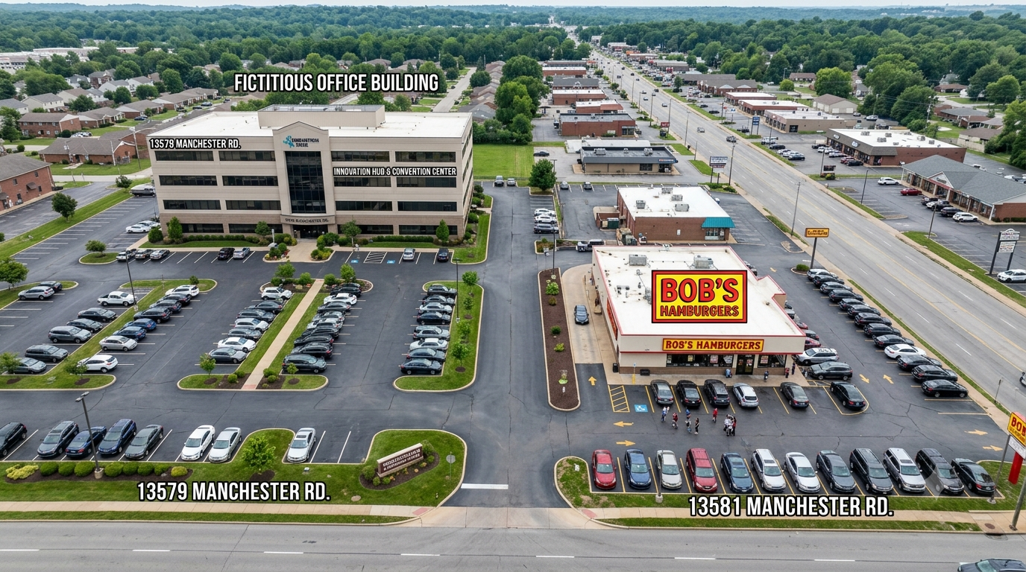
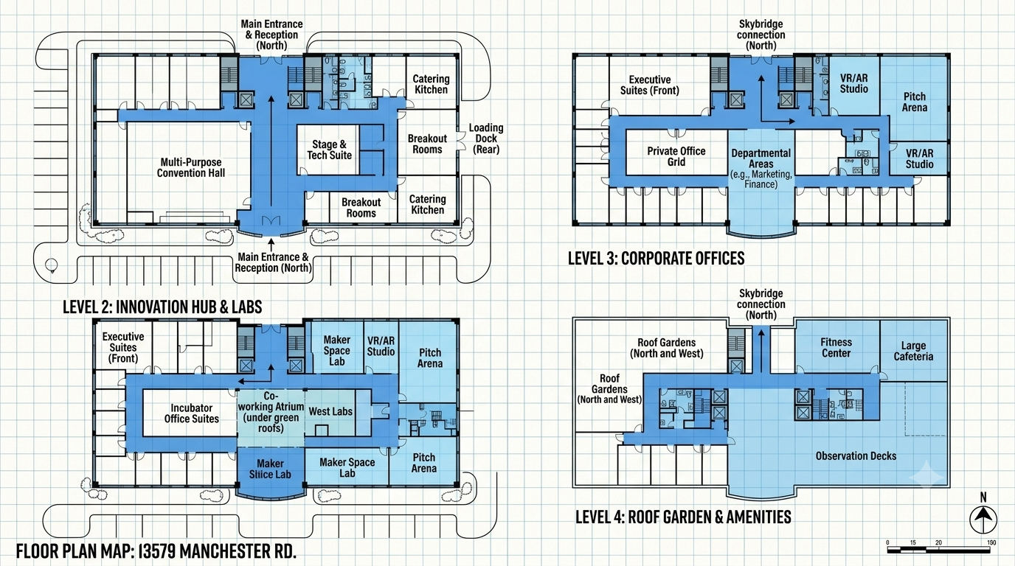

Alerts:
In the event of an emergency, employees are alerted by:
- The Sounding of an alarm
- Public Address system announcement
Identify the emergency signal for each emergency situation (i.e. earthquake, fire, general evacuation):
The fire alarm consists of a repeating pattern of a klaxon horn sound of three pulses and then a short pause. The sound is accompanied by a white flashing light.

Policy:
In the event of fire, fire alarm sounding or other emergency, ALL employees and occupants shall evacuate the building immediately using the nearest marked “EXIT” doors, even if no fire or smoke is visible.

Routes:
In the event of an emergency, employees shall evacuate by means of the nearest available marked exit.

Extinguishers:
In the event of a fire, the following individuals are authorized to use portable fire extinguishers to attempt to extinguish fires before evacuating:
- Any employee that has their immediate egress or that of another employee in their immediate area threatened by a visible fire may use an extinguisher to attempt to suppress the fire for evacuation.
- No employee should use an extinguisher to seek a source of an unknown fire or attempt to extinguish a fire that is not in the direct path of egress for themselves or persons in their immediate area.

Operations:
In the event of an emergency, the following employees are to remain in the workplace to shutdown or monitor critical operations before they evacuate:
- Any employee should provide assistance to any other employee or guest who may require assistance with egress.
- Employees shall not delay evacuation in order to shut-down computer terminals and workstations
- Employees in Sections 2-A Human Resources and 4-C Accounting shall ensure that their office doors are locked upon exiting.
Duties:
No employees are assigned to perform medical or rescue duties during emergency evacuation situations.
Assembly:
After an emergency evacuation, employees are to gather in the following location(s):
- The primary rally point for ALL evacuated occupants shall be at the north end of the parking lot below the sign.
- If the Primary location is not accessible, the Secondary Rally Point shall be below the northwest corner of the parking lot of Bob's Hamburgers at 13591 Manchester Rd.
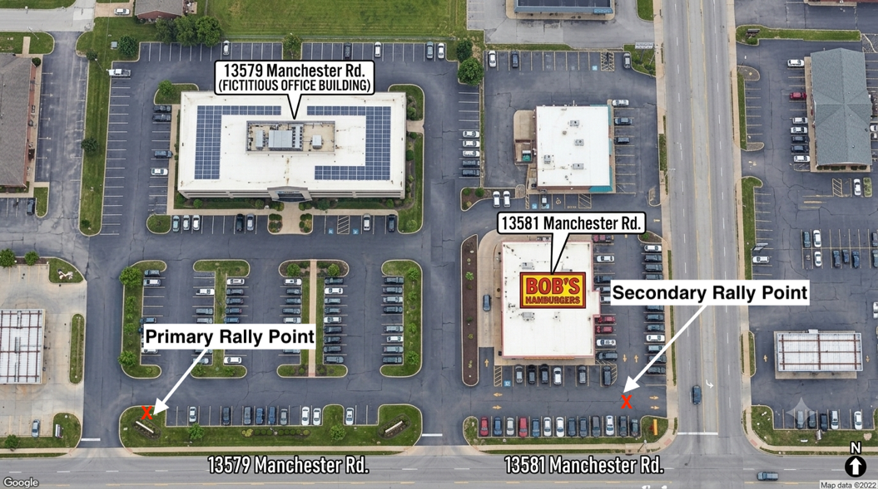
Accounting:
After an emergency evacuation, the procedure for accounting for all employees is:
Upon exiting the building, each employee shall do the following:
- Immediately head to the Primary Rally Point.
- If the Primary Rally Point is inaccessible, the employee shall head to the Secondary Rally Point.
- Report to the Rally Manager. Provide them with your name, cell phone number and the names of any other guests or non-employee occupants that are with you.
- Report to the Rally Manager the location of any fire, medical emergency or critical information that you have DIRECT knowledge of. Do not speculate.
- Remain at the Rally Point unless further instructed by the Rally Manager.
- Do not head to your vehicle or leave the scene unless approved by the Rally Manager.
- DO NOT RE-ENTER THE STRUCTURE unless the Rally Manager declares it is safe to return.

Additional Information:
An initial call to 911 should be made when an emergency is first discovered, however multiple calls to 911 to report general information or speculative information can overwhelm the 911 call centers or dispatchers and delay receipt of critical information.

If prior to reaching the Rally Point anyone has CRITICAL information about the emergency that results from first-hand witness of the emergency (visual presence of fire, visible presence of smoke, visible injury to a person, visible entrapment of a person, person audibly pleading for someone to call 911, visible or audible explosion, intruder, etc.) a direct call to 911 should be made to provide responders with this CRITICAL information. Also report the information to the Rally Manager upon reaching the Rally Point.

All information about the nature of the emergency, status of evacuation accountability, etc. shall be provided by the occupants up to the Rally Manager. The Rally Manager, or their direct designee, shall act as a single-point liaison with the fire incident commander upon their arrival.

When fire crews arrive, the person riding in the right front seat of the fire truck is the Captain in charge of that fire apparatus’ crew. CRITICAL information about the KNOWN location of a fire/explosion/emergency/injury/entrapment should be provided by the Rally Manager or their designee to the Captain of the FIRST fire apparatus arriving on scene.

Overall command of the scene is handled by the fire chief officer typically located at the rear of the fire SUV with the rear open hatch/tailgate. Upon the arrival of this fire incident commander, all contact with fire/EMS responders should be handled thru this commander instead of with any responder unless specifically instructed otherwise.

The results of an occupant accountability assessment shall be reported to the fire commander as soon as it has been completed. If asked by emergency responders if everyone is out and you are not sure, simply tell the responders that you are not sure. PLEASE DO NOT SPECULATE.

EMPLOYEE EVACUATION ACCOUNTABILITY FORM

(Complete for each floor and each occupant as appliable)

Date | __________________________________________
Company | __________________________________________
Floor Manager | __________________________________________

Accountability Checks
☐ 1st Accountability Check ____:____ am / pm. ☐ 2nd Accountability Check____:____ am / pm
☐ 3rd Accountability Check____:____ am / pm. ☐ 4th Accountability Check____:____ am / pm

Missing Persons

Name Cell Last Known Location
1
2
3
4
5
6
7
8
9
10

Notes

Completed By | __________________________________________
Time | __________________________________________
Signature | __________________________________________

